IT3037
Lab#03: AWS Elastic Block Store (EBS) and Snapshots

In this lab, you will study Amazon EBS and create snapshots. You will use the AWS CLI commands to create an EBS volume and an EBS snapshot. Also, you will create a volume from a snapshot.

Tools and Materials

- Amazon AWS security credentials.
- AWS CLI
- Ubuntu Command Line

Note: You need to replace words in italics with your information. Questions will be in red.
Part 1. Create a new EBS volume
    - Please start your Ubuntu VM image and connect to the VM.

- Create a new EBS volume via the following command:
aws ec2 create-volume --size 1 --region us-east-1 --availability-zone us-east-1a

What does this command mean? What is the output?
creates a 1 GiB EBS volume in the us-east-1a availability zone of the us-east-1 region.
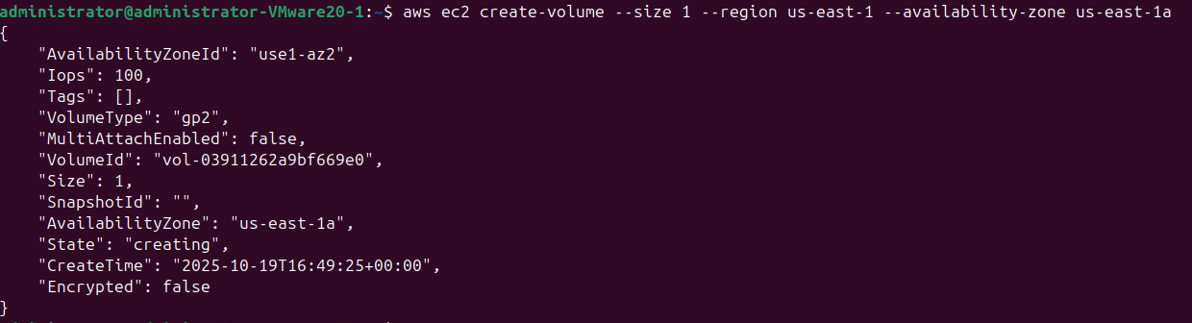
Volume ID: vol-07aed90fb92788a4d
- Describes your EBS volume via the following command:
aws ec2 describe-volume-status --volume-ids volume_id
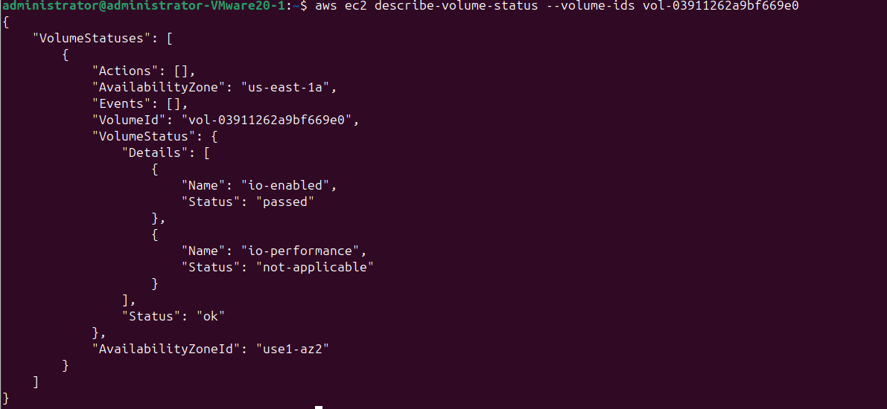
You can get the volume_id of the EBS volume from the output of step 2. What is the output?
vol-03911262a9bf669e0

- Create an instance via the following:

aws ec2 run-instances --image-id ami-013f17f36f8b1fefb --count 1 --instance-type t1.micro \
--key-name your_key --security-group-ids <your security group id> --subnet-id your subnet id \
--associate-public-ip-address

aws ec2 run-instances --image-id ami-013f17f36f8b1fefb --count 1 --instance-type t1.micro \
--key-name usersam2-key --security-group-ids sg-0e8b8b55ca4766f03 --subnet-id subnet-048109d99999c8dae \ --associate-public-ip-address

Key: usersam2-key
GroupId: sg-0e8b8b55ca4766f03
Subnet: subnet-0285dcfd54e48bc45

aws ec2 run-instances \
--image-id ami-013f17f36f8b1fefb \
--count 1 \
--instance-type t3.micro \
--key-name usersam2-key \
--security-group-ids sg-0e8b8b55ca4766f03 \
--subnet-id subnet-048109d99999c8dae \
--associate-public-ip-address \
--region us-east-1

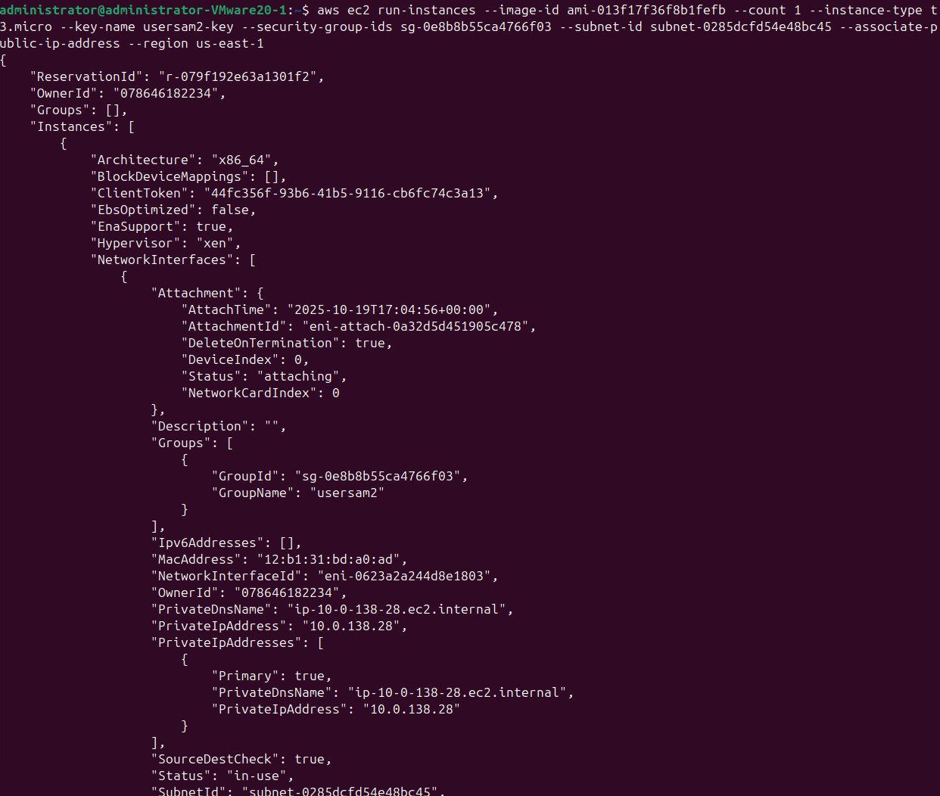

- Attach the EBS volume to the instance and exposes it as /dev/sdf via the following:
Instance ID: i-0c1e03818c46e37dc
aws ec2 attach-volume --volume-id volume_id --instance-id instance_id --device /dev/sdf
aws ec2 attach-volume --volume-id vol-07aed90fb92788a4d --instance-id i-0c1e03818c46e37dc --device /dev/sdf

What is the output?

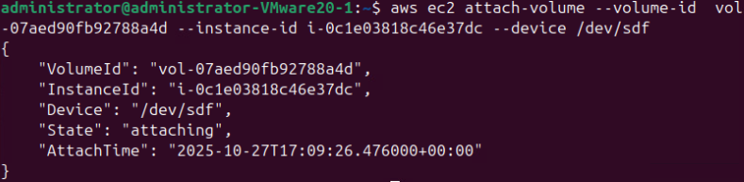

- Log into the EC2 instance via ssh. Switch to root. Create a file system on the EBS volume and mount the volume via the following commands. Note that depending on the block device driver of the kernel, the device might be attached with a different name than what you specify. For example, if you specify a device name of /dev/sdf, your device might be renamed/dev/xvdf by the kernel; in most cases, the trailing letter remains the same. Run “lsblk” on the terminal to view your available disk devices and their mount points (if applicable) to help you determine the correct device name to use. Assume that the device is renamed /dev/xvdf by the kernel. 10.0.138.28

18.206.231.179

mkfs -F /dev/xvdf
What is the output?
mke2fs 1.44.1 (24-Mar-2018)
The file /dev/xvdf does not exist and no size was specified.
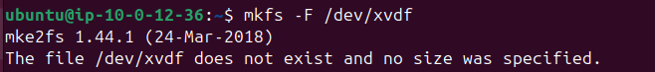

mkdir /data
mount /dev/xvdf /data
cd /data/
df

What is the output?
Filesystem 1K-blocks Used Available Use% Mounted on
udev 473632 0 473632 0% /dev
tmpfs 97624 752 96872 1% /run
/dev/nvme0n1p1 8065444 1189628 6859432 15% /
tmpfs 488108 0 488108 0% /dev/shm
tmpfs 5120 0 5120 0% /run/lock
tmpfs 488108 0 488108 0% /sys/fs/cgroup
/dev/loop0 31872 31872 0 100% /snap/snapd/11036
/dev/loop1 56832 56832 0 100% /snap/core18/1988
/dev/loop2 34176 34176 0 100% /snap/amazon-ssm-agent/3552
tmpfs 97620 0 97620 0% /run/user/1000

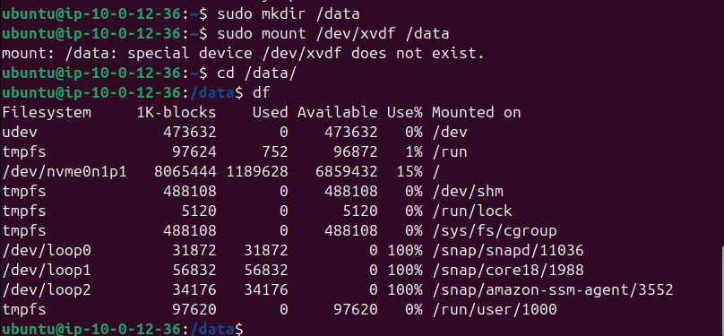

Part 2. EBS Snapshots

- Create a file named IT3037c.txt and chmod 777 the file and type anything you want in the file. Let’s create a backup of your EBS volume. The first step is to make sure that any in-memory data has been written to the volume (disk). Run the sync command in the terminal of the EC2 instance (Make sure to run the sync command on root and the user). The following is how I ran the sync command.

ubuntu@ip-192-168-2-8:/data$ sync
root@ip-192-168-2-8:/data# sync

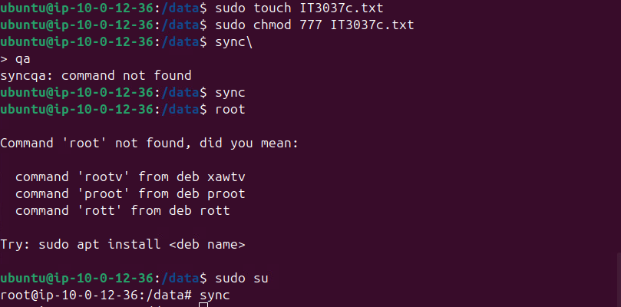
- Open another VM terminal. Create a snapshot (backup) of your EBS volume via the following:

aws ec2 create-snapshot --volume-id volume_id --description "This is my volume snapshot."
aws ec2 create-snapshot --volume-id vol-07aed90fb92788a4d --description "This is my volume snapshot."

volume_id is from the step 2. What is the output?
{
"Tags": [],
"SnapshotId": "snap-096693537a637319c",
"VolumeId": "vol-07aed90fb92788a4d",
"State": "pending",
"StartTime": "2025-10-27T19:55:15.780000+00:00",
"Progress": "",
"OwnerId": "078646182234",
"Description": "This is my volume snapshot.",
"VolumeSize": 1,
"Encrypted": false
}

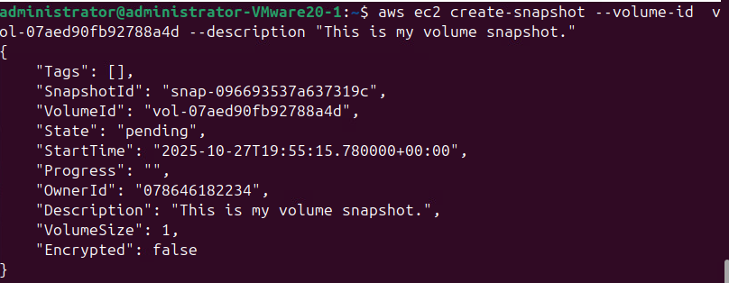
- Check on the status of your snapshot via the following command:
aws ec2 describe-snapshots --snapshot-id snapshot_id
aws ec2 describe-snapshots --snapshot-id snap-096693537a637319c

You can get snapshot_id from the output of step 8. What is the output? Check on the status of the snapshot until you see the snapshot’s state transitions to “completed”. The “completed” means the volume has been backed up.
{
"Snapshots": [
{
"StorageTier": "standard",
"TransferType": "standard",
"CompletionTime": "2025-10-27T19:56:05.908000+00:00",
"FullSnapshotSizeInBytes": 0,
"SnapshotId": "snap-096693537a637319c",
"VolumeId": "vol-07aed90fb92788a4d",
"State": "completed",
"StartTime": "2025-10-27T19:55:15.780000+00:00",
"Progress": "100%",
"OwnerId": "078646182234",
"Description": "This is my volume snapshot.",
"VolumeSize": 1,
"Encrypted": false
}
]
}

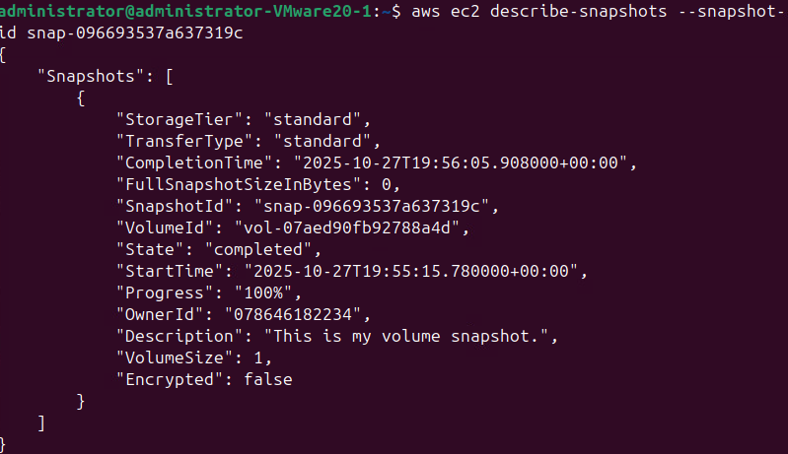

- Now let’s create a new volume with the snapshot via the following:
aws ec2 create-volume --region us-east-1 --availability-zone us-east-1a --snapshot-id snapshot_id
aws ec2 create-volume --region us-east-1 --availability-zone us-east-1a --snapshot-id snap-096693537a637319c

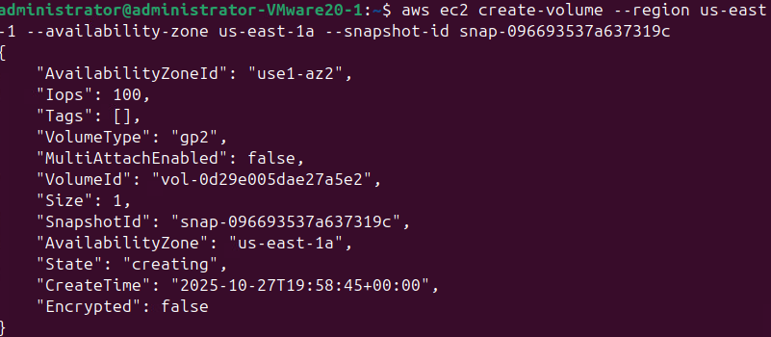

What is the output? You can get the snapshot_id from the output of step 8.
{
"AvailabilityZoneId": "use1-az2",
"Iops": 100,
"Tags": [],
"VolumeType": "gp2",
"MultiAttachEnabled": false,
"VolumeId": "vol-0d29e005dae27a5e2",
"Size": 1,
"SnapshotId": "snap-096693537a637319c",
"AvailabilityZone": "us-east-1a",
"State": "creating",
"CreateTime": "2025-10-27T19:58:45+00:00",
"Encrypted": false
}

- Check on the status of the volume. What command did you run to check on the status? What is the output?
aws ec2 describe-volumes --volume-ids vol-07aed90fb92788a4d --region us-east-1 --query "Volumes[*].{ID:VolumeId,State:State,Size:Size,AZ:AvailabilityZone}" --output table

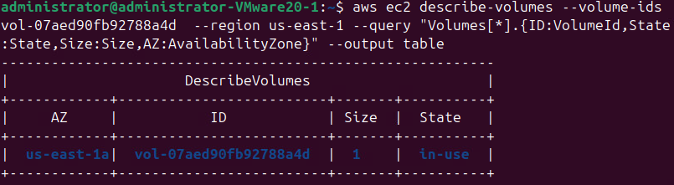

- Attach the new volume to the instance via the following:
aws ec2 attach-volume --volume-id your_volume_id --instance-id your_instance_id --device /dev/sdg
aws ec2 attach-volume --volume-id vol-07aed90fb92788a4d --instance-id i-0c1e03818c46e37dc --device /dev/sdg

The volume_id is from the output of step 10. The instance_id is from the output of step 4. What is the output?
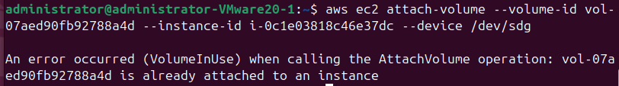

- Switch to the EC2 instance terminal.

- On the EC2 instance terminal, create a mount point /data2 and then mount the new volume to /data2. What commands did you run?

sudo mkdir /data2
sudo mkfs -t ext4 /dev/nvme1n1
sudo mount /dev/nvme1n1 /data2
df -h
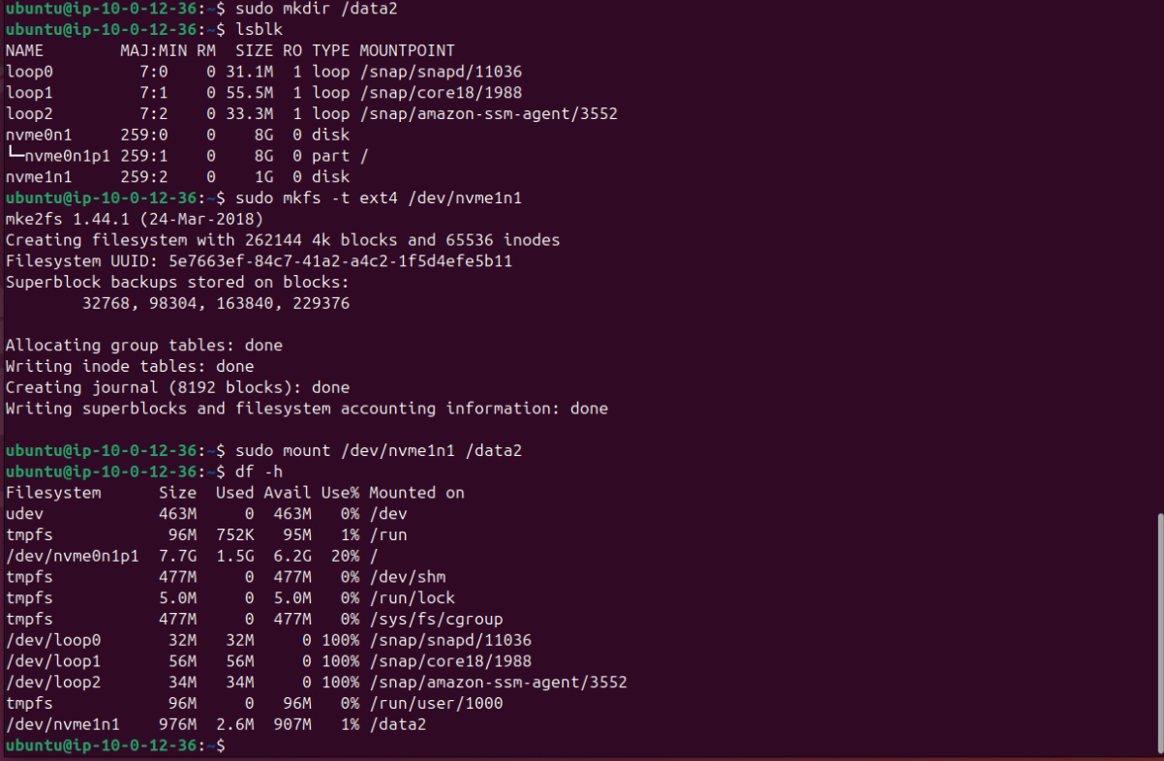

- Go to /data2./data

Did you see testfile.txt?
-rw-r--r-- 1 root root 0 Oct 27 23:08 IT3037c.txt
drwx------ 2 root root 16384 Oct 27 23:03 lost+found
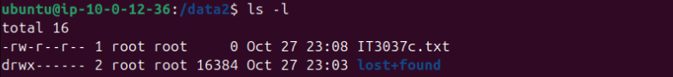
Clean-up

- Umount, detach, and destroy the volumes. The following is how I did:
root@ip-10-45-185-154:/data2# cd /
root@ip-10-45-185-154:/# umount /dev/xvdf
root@ip-10-45-185-154:/# umount /dev/xvdg

Switch to the VM terminal. Detach and delete the first volume, which was created in step 2.

aws ec2 detach-volume --force --volume-id volume_id
aws ec2 detach-volume --force --volume-id vol-07aed90fb92788a4d
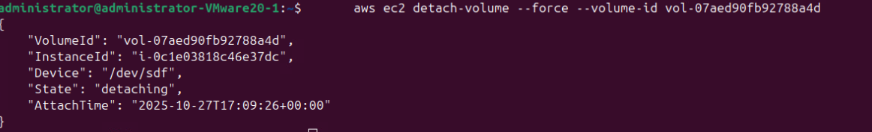

Wait for 10 seconds so that the volume is detached. Then delete the volume via the following

aws ec2 delete-volume --volume-id volume_id
aws ec2 delete-volume --volume-id vol-07aed90fb92788a4d

The volume_id is from step 2. What are the outputs?

Please detach and delete the second volume, which was created in step 10. What commands did you run? What are the outputs?
aws ec2 detach-volume --force --volume-id-0d29e005dae27a5e2
aws ec2 delete-volume --volume-id vol-0d29e005dae27a5e2

Delete the snapshot via the following:
aws ec2 delete-snapshot --snapshot-id snapshot_id
aws ec2 delete-snapshot --snapshot-id snap-096693537a637319c

snapshot_id is from step 8.

What is the output?

aws ec2 terminate-instances --instance-ids <your-instance-id>
aws ec2 terminate-instances --instance-ids i-0c1e03818c46e37dc

What is the output?
{
"TerminatingInstances": [
{
"InstanceId": "i-0c1e03818c46e37dc",
"CurrentState": {
"Code": 32,
"Name": "shutting-down"
},
"PreviousState": {
"Code": 16,
"Name": "running"
}
}
]
}
admi
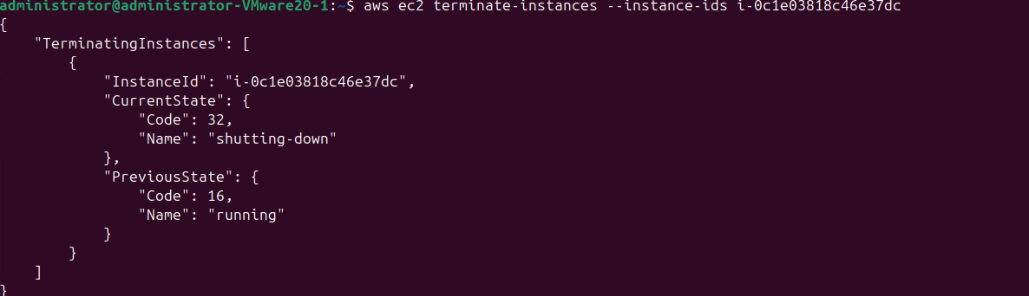
aws ec2 describe-instances --instance-ids <your-instance-id>
aws ec2 describe-instances --instance-ids i-0c1e03818c46e37dc

What is the output?

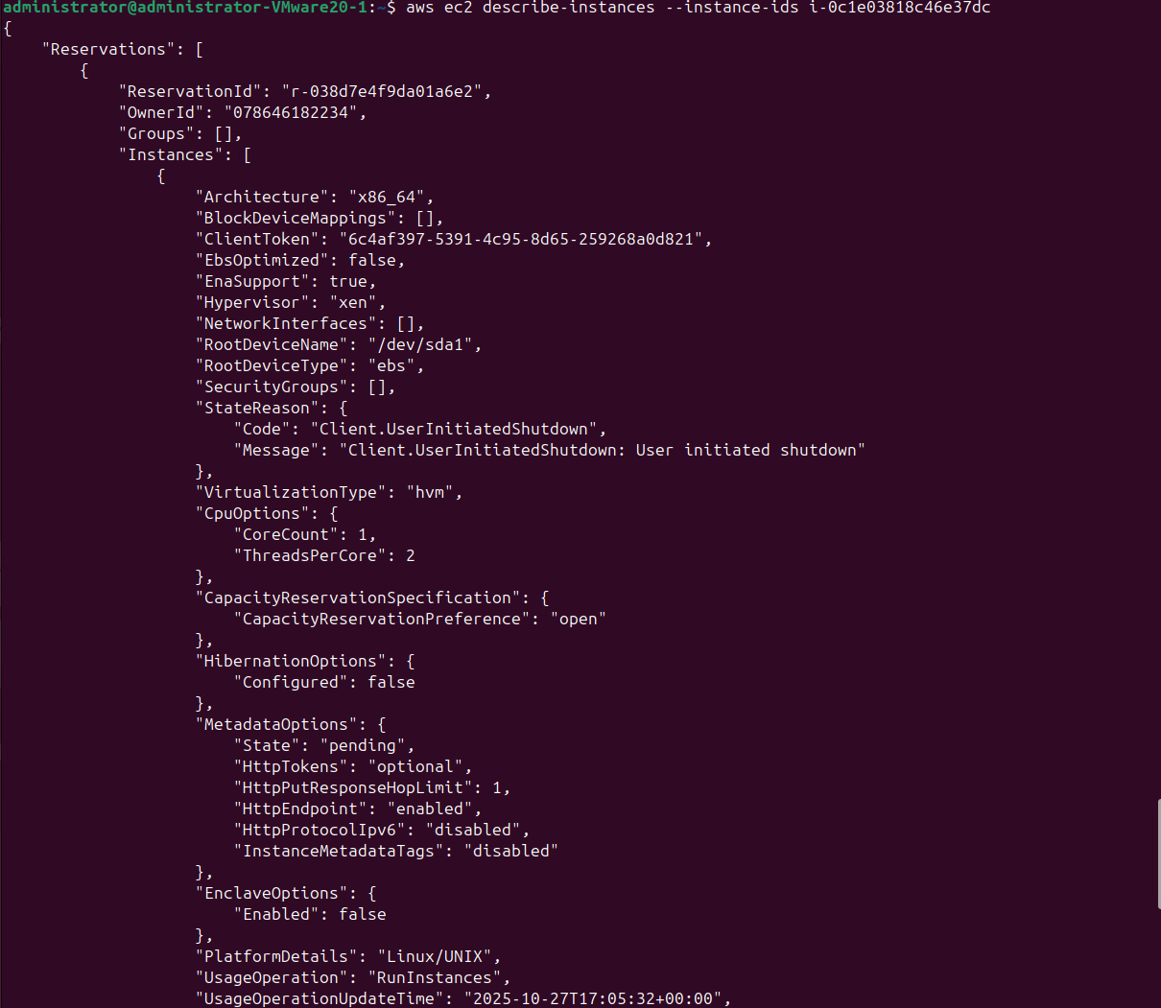
Part 3. EBS RAID

- Switch to the VM terminal. Create two 1 GB volumes in Availability Zone us-east-1a. What commands did you run? What are the outputs?
aws ec2 create-volume --availability-zone us-east-1a --size 1 --volume-type gp2 --region us-east-1
aws ec2 create-volume --availability-zone us-east-1a --size 1 --volume-type gp2 --region us-east-1

{
"AvailabilityZoneId": "use1-az2",
"Iops": 100,
"Tags": [],
"VolumeType": "gp2",
"MultiAttachEnabled": false,
"VolumeId": "vol-06f74aee715392ebf",
"Size": 1,
"SnapshotId": "",
"AvailabilityZone": "us-east-1a",
"State": "creating",
"CreateTime": "2025-10-27T23:22:29+00:00",
"Encrypted": false
}

{
"AvailabilityZoneId": "use1-az2",
"Iops": 100,
"Tags": [],
"VolumeType": "gp2",
"MultiAttachEnabled": false,
"VolumeId": "vol-0df5f221898ebea04",
"Size": 1,
"SnapshotId": "",
"AvailabilityZone": "us-east-1a",
"State": "creating",
"CreateTime": "2025-10-27T23:22:39+00:00",
"Encrypted": false
}

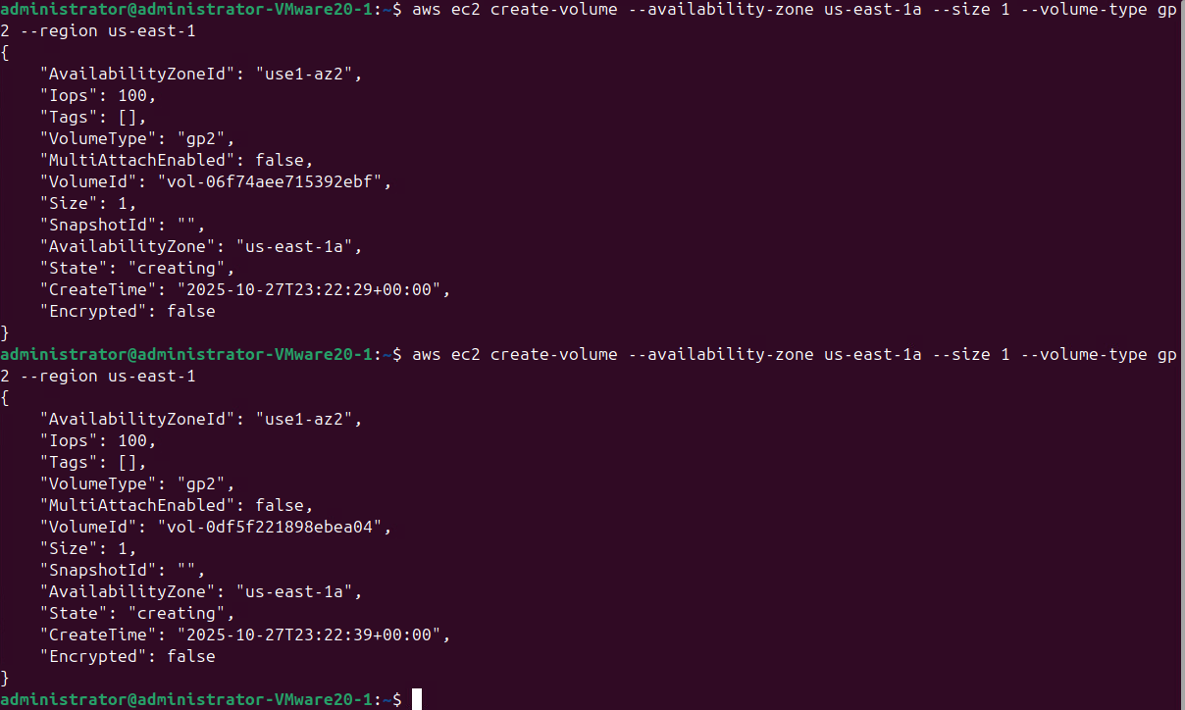
- Attach two volumes to the EC2 instance and expose them as /dev/sdf and /dev/sdg, respectively. What commands did you run? What are the outputs?

aws ec2 attach-volume --volume-id vol-06f74aee715392ebf --instance-id i-0d6f2f736b30b6484 --device /dev/sdf --region us-east-1
aws ec2 attach-volume --volume-id vol-0df5f221898ebea04 --instance-id i-0d6f2f736b30b6484 --device /dev/sdg --region us-east-1

{
"VolumeId": "vol-06f74aee715392ebf",
"InstanceId": "i-0d6f2f736b30b6484",
"Device": "/dev/sdf",
"State": "attaching",
"AttachTime": "2025-10-27T23:30:57.084000+00:00"
}

{
"VolumeId": "vol-0df5f221898ebea04",
"InstanceId": "i-0d6f2f736b30b6484",
"Device": "/dev/sdg",
"State": "attaching",
"AttachTime": "2025-10-27T23:32:33.790000+00:00"
}

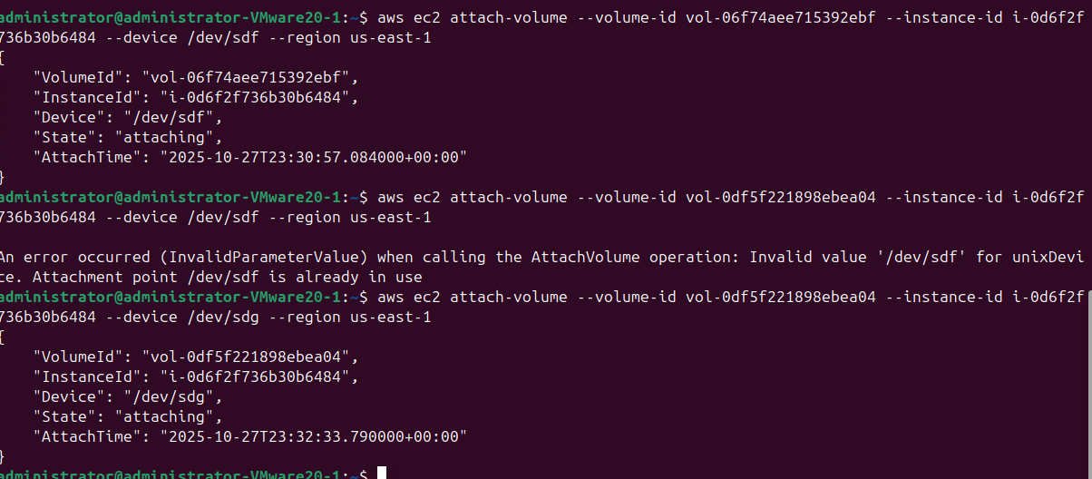

- Switch to the EC instance terminal. Install software RAID via the following command:

apt-get update
apt-get install mdadm

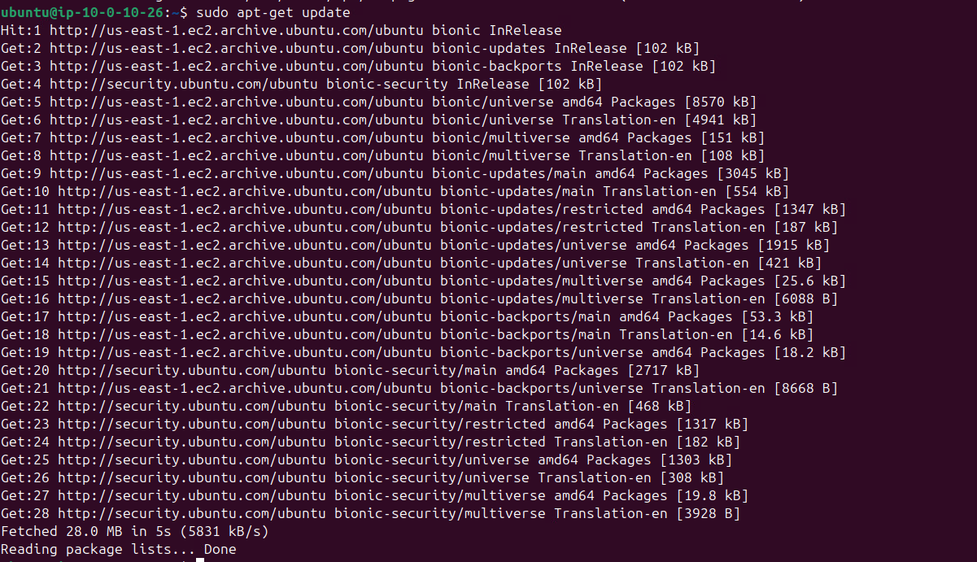
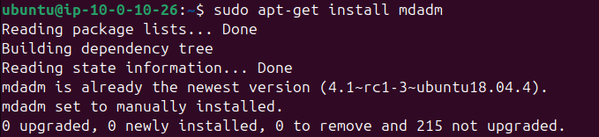

- Build a RAID 0 array on two volumes via the following command:
mdadm --create /dev/md0 --level 0 --metadata=1.1 --raid-devices 2 the_renamed_name_of_/dev/sdf the_renamed_name_of_/dev/sdg

You can follow instructions on step 6 to find out the_renamed_name_of_/dev/sdh1 and the_renamed_name_of_/dev/sdh2.

sudo mdadm --create /dev/md0 --level=0 --metadata=1.1 --raid-devices=2 /dev/nvme1n1 /dev/nvme2n1mdadm: array /dev/md0 started.

What is the output?

- Check the status of the RAID 0 array via the following command:

mdadm --detail /dev/md0

What is the output?
Version : 1.1
Creation Time : Mon Oct 27 23:41:56 2025
Raid Level : raid0
Array Size : 2093056 (2044.00 MiB 2143.29 MB)
Raid Devices : 2
Total Devices : 2
Persistence : Superblock is persistent

Update Time : Mon Oct 27 23:41:56 2025
State : clean
Active Devices : 2
Working Devices : 2
Failed Devices : 0
Spare Devices : 0

Chunk Size : 512K

Consistency Policy : none

Name : ip-10-0-10-26:0 (local to host ip-10-0-10-26)
UUID : f99b26fb:a2fe145f:5319b0ce:8a3281a1
Events : 0

Number Major Minor RaidDevice State
0 259 2 0 active sync /dev/nvme1n1
1 259 3 1 active sync /dev/nvme2n1

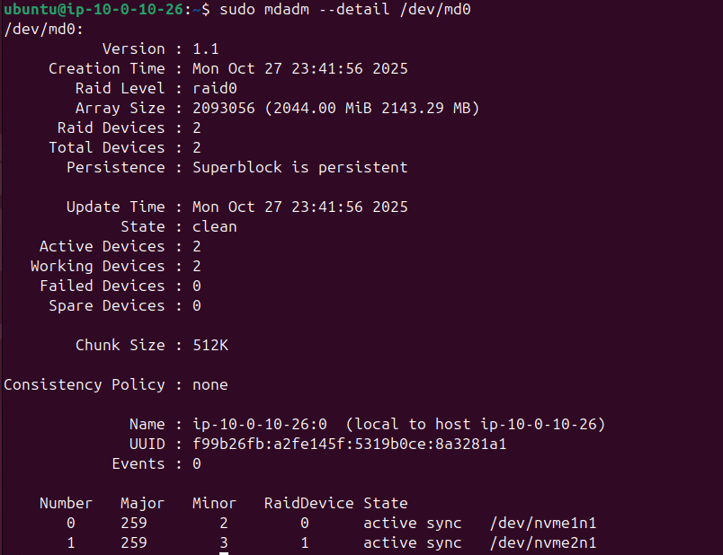

- Create a file system on the RAID 0 array and mount the RAID 0 array via the following:
mkfs /dev/md0
mkdir /data3
mount /dev/md0 /data3

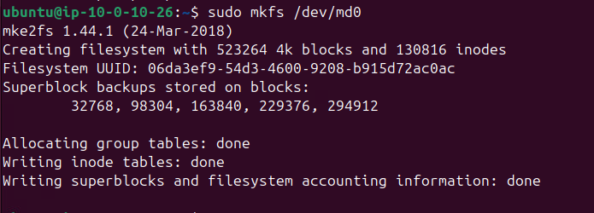
Please run “df”. What is the output?
Filesystem 1K-blocks Used Available Use% Mounted on
udev 473632 0 473632 0% /dev
tmpfs 97624 768 96856 1% /run
/dev/nvme0n1p1 8065444 1414060 6635000 18% /
tmpfs 488108 0 488108 0% /dev/shm
tmpfs 5120 0 5120 0% /run/lock
tmpfs 488108 0 488108 0% /sys/fs/cgroup
/dev/loop0 31872 31872 0 100% /snap/snapd/11036
/dev/loop1 56832 56832 0 100% /snap/core18/1988
/dev/loop2 34176 34176 0 100% /snap/amazon-ssm-agent/3552
tmpfs 97620 0 97620 0% /run/user/1000
/dev/md0 2060176 3072 1952452 1% /data3

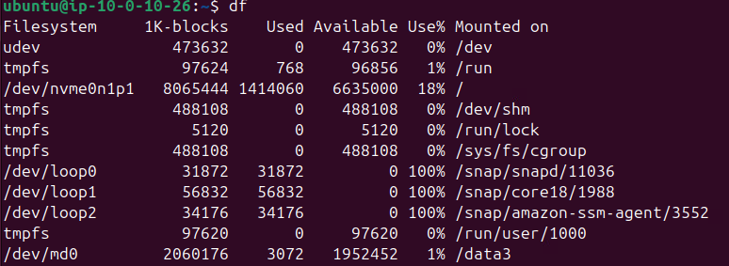

- Stop the RAID 0 array via the following:
cd /
umount /dev/md0
mdadm --stop /dev/md0
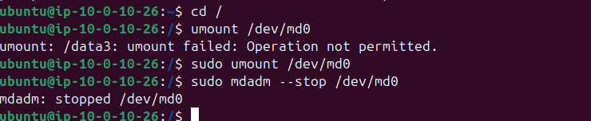

- Switch to the VM terminal. Please detach and delete two EBS volumes. What commands did you run? What are the outputs?

aws ec2 detach-volume --volume-id vol-0df5f221898ebea04 --region us-east-1
aws ec2 detach-volume --volume-id vol-06f74aee715392ebf --region us-east-1

{
"VolumeId": "vol-0df5f221898ebea04",
"InstanceId": "i-0d6f2f736b30b6484",
"Device": "/dev/sdg",
"State": "detaching",
"AttachTime": "2025-10-27T23:32:33+00:00"
}

{
"VolumeId": "vol-06f74aee715392ebf",
"InstanceId": "i-0d6f2f736b30b6484",
"Device": "/dev/sdf",
"State": "detaching",
"AttachTime": "2025-10-27T23:30:57+00:00"
}

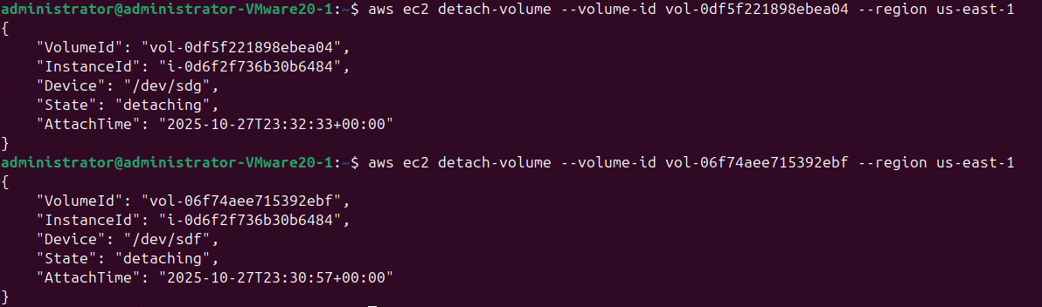

- Please terminate your EC2 instance. What command did you run? What is the output?

aws ec2 delete-volume --volume-id vol-0df5f221898ebea04 --region us-east-1
aws ec2 delete-volume --volume-id vol-06f74aee715392ebf --region us-east-1

Submission instruction

After completing this work, submit this word document with your answers to the Canvas. In your word document, your answers should be in blue font.

